PRACTICAL NO -1

Q.1) A) Design a simple neural network with one input node and one output node. Calculate .net input of the network.

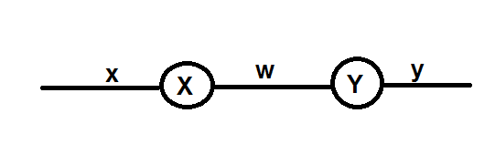

CODE:

print(‘shubham kale , 15)  
print("Input x=")  
x=float(input())  
print("Weight W= ")  
w=float(input())  
yin=x*w  
print("Input x= ",x)  
print("Input w= ",w)  
print("Input yin= ",yin)

OUTPUT:

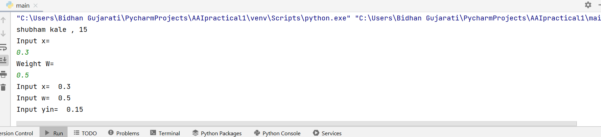

Q.1) B) Design the following neural network.

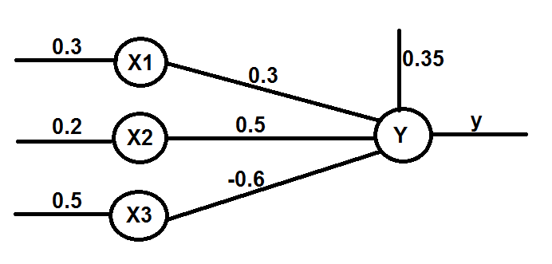

CODE:  
print(‘shubham kale , 15’)  
  
print("input x1= ")  
x1=float(input())  
print("Input x2= ")  
x2=float(input())  
print("Input x3= ")  
x3=float(input())  
  
print("Input Weight w1= ")  
w1=float(input())  
print("Input Weight w2= ")  
w2=float(input())  
print("Input Weight w3= ")  
w3=float(input())  
  
print("Input Bias b= ")  
b=float(input())  
  
yin=b+(x1*w1+x2*w2+x3*w3)  
  
if yin>=0:  
 y=1  
else:  
 y=0  
  
print("Inputs are:")  
print("x1=",x1)  
print("x2=",x2)  
print("x3=",x3)  
  
print("Weights are:")  
print("w1=",w1)  
print("w2=",w2)  
print("w3=",w3)  
  
print("Bias b= ",b)  
  
print("Net Input yin = ",yin)  
print("Output= ",y)

OUTPUT:

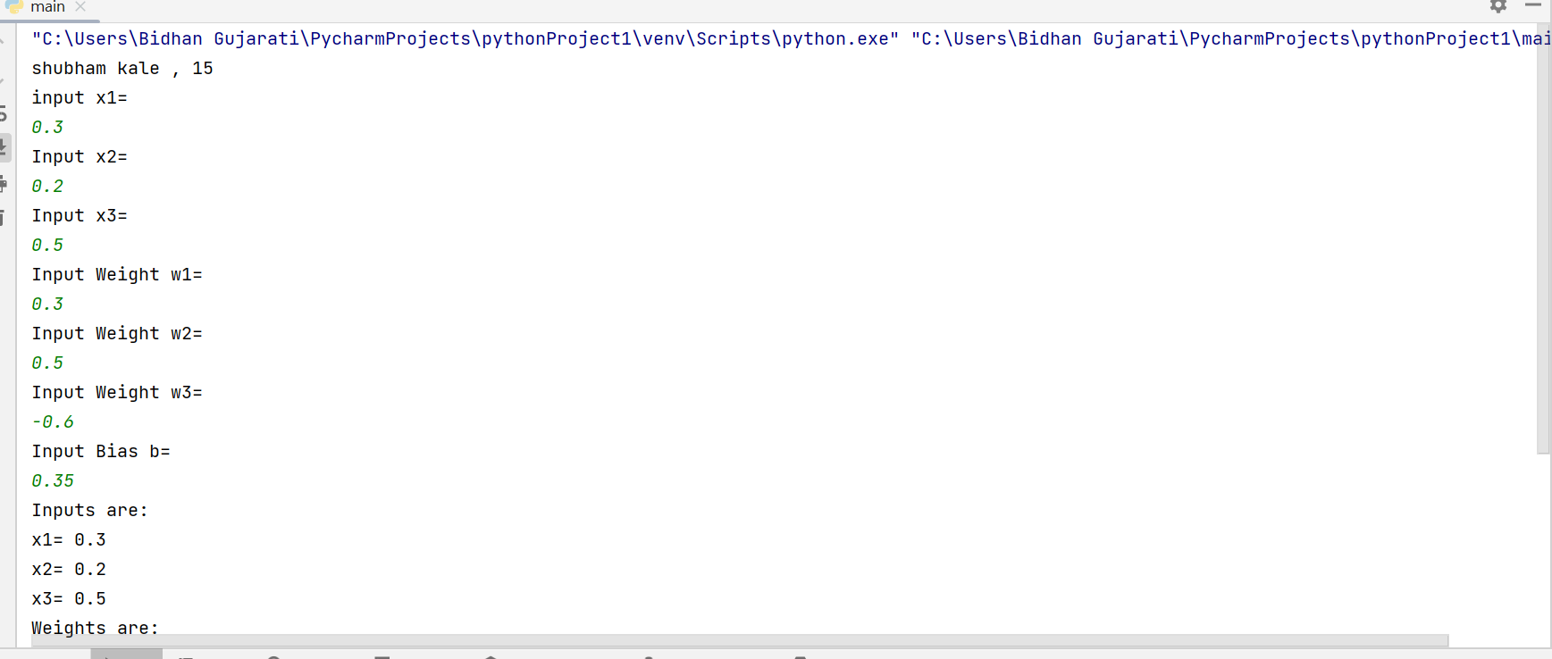

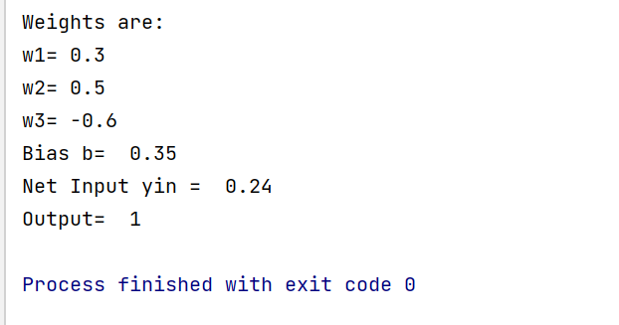

PRACTICAL No-2

1) Calculate the output of the neuron Y for the network shown below. Use binary and bipolar sigmodial activation function.

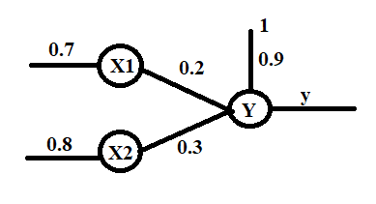

CODE:

print(‘shubham kale , 15’)

import math

print("Input x1= ")

x1=float(input())

print("Input x2= ")

x2=float(input())

print("Input weight w1= ")

w1=float(input())

print("Input weight w2= ")

w2=float(input())

print("Input Bias b=")

b=float(input())

print()

yin=b+(x1*w1+x2*w2)

y1=1/(1 + math.exp(-yin))

y2=(2/(1 + math.exp(-yin)))-1

print("Inputs are: ")

print("x1=",x1)

print("x2=",x2,'\n')

print("Weights are:")

print("w1=",w1)

print("w2=",w2,'\n')

print("Bias b=",b)

print("Net Input=",yin,'\n')

print("Binary Sigmodial Activation Function")

print("Output=",y1,'\n')

print("Bipolar Sigmodial Activation Function")

print("Output=",y2)

OUTPUT:

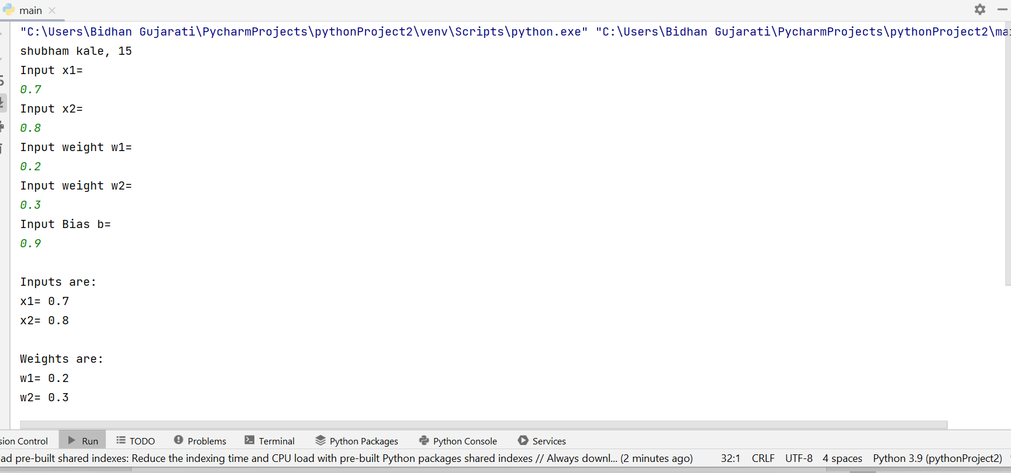

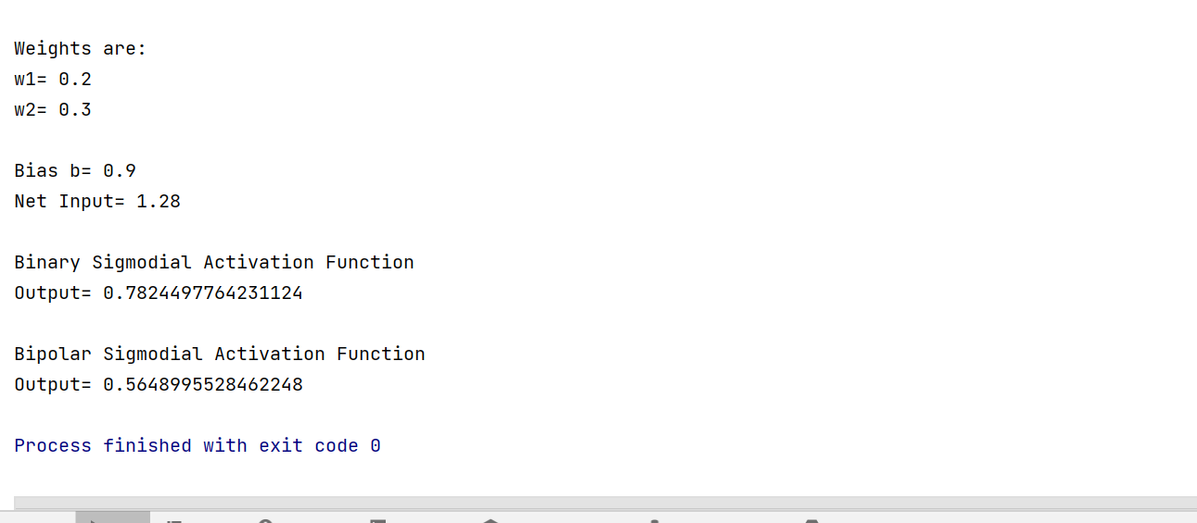

Practical No-3

Q.3) Design a simple machine learning model to train the training instances and test the same

Code:

print(‘shubham kale, 15)

import random;

from sklearn.linear_model import LinearRegression

*#Create an empty list for the feature data set 'X' and target data set 'Y'*

feature_set=[]

target_set=[]

*#get the number of rows wanted for data set*

number_of_rows=200

*#limit the possible values in data set*

random_number_limit=2000

*#Create the training data*

*#Create and append a randomly generated data set to input and output*

for i in range(0,number_of_rows):

x = random.randint(0,random_number_limit)

y = random.randint(0, random_number_limit)

z = random.randint(0, random_number_limit)

print("x=",x,"\t y=",y,"\t z=",z)

function=(10*x)+(2*y)+(3*z)

feature_set.append([x,y,z])

target_set.append(function)

*#Create linear regression model/object*

model=LinearRegression()

model.fit(feature_set,target_set)

test_set=[[1,3,5]]

prediction=model.predict(test_set)

print("Prediction:"+str(prediction)+'\t'+'Coefficient:'+str(model.coef_))

OUTPUT:

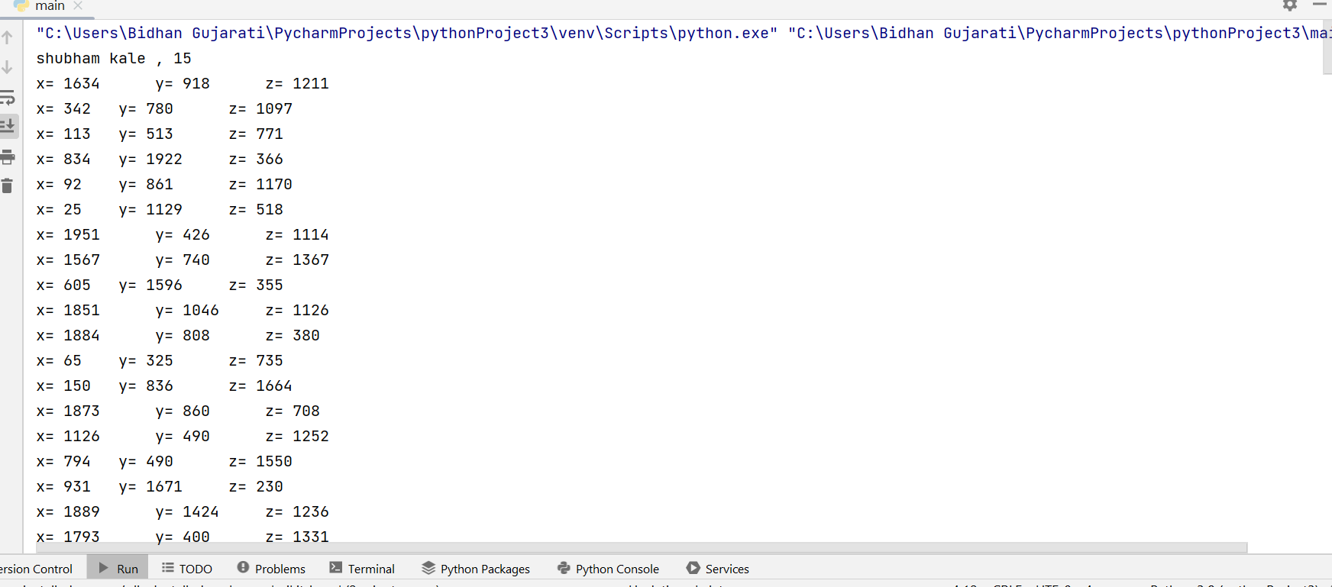

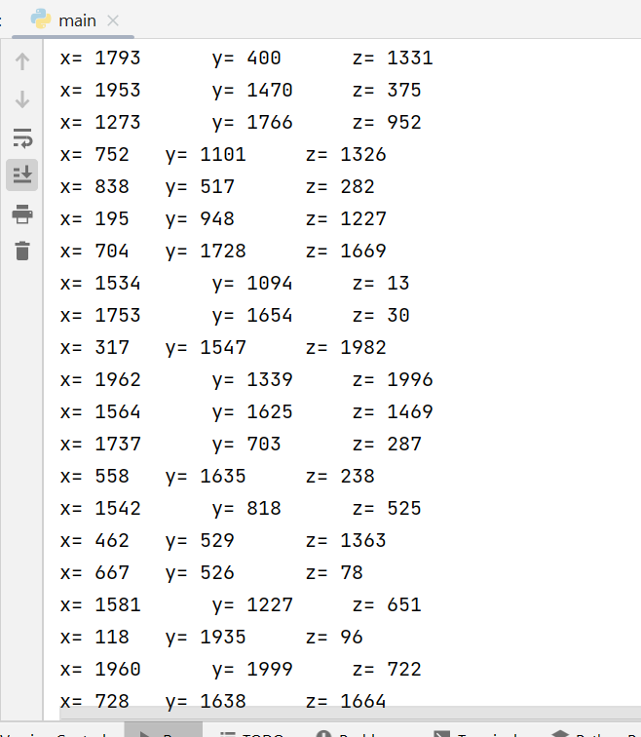

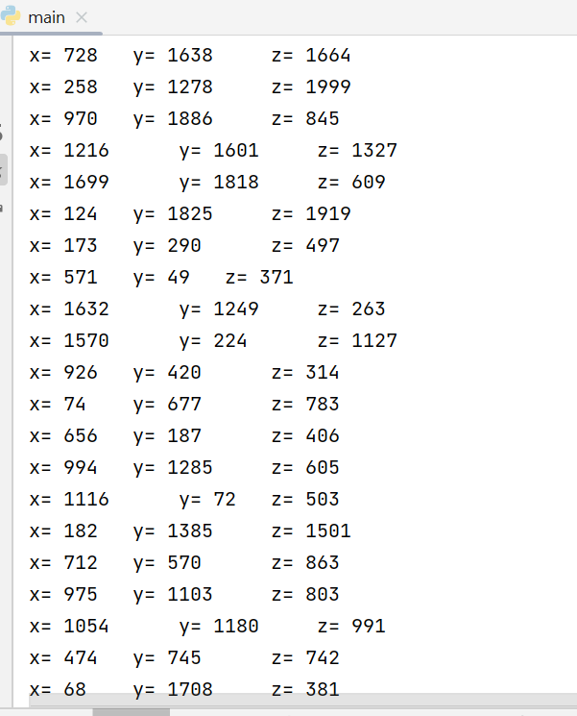

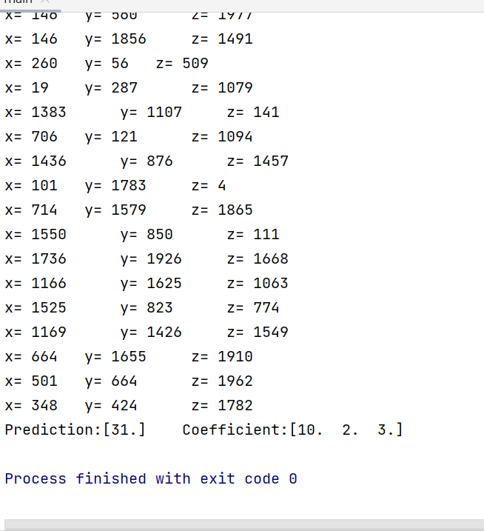

Practical No-4

Q.4) Find Ratios using Fuzzy logic and Calculate the levenshtein distance similarity ratios between the two strings (Sequence).

CODE:

print(‘shubham kale , 15)  
  
from fuzzywuzzy import fuzz  
from fuzzywuzzy import process  
  
s1="I like soft computing"  
s2="I like hard computing"  
print("FuzzyWuzzy Ratio: ",fuzz.ratio(s1,s2))  
print("FuzzyWuzzy PartialRatio: ",fuzz.partial_ratio(s1,s2))  
print("FuzzyWuzzy TokenSortRatio: ",fuzz.token_sort_ratio(s1,s2))  
print("FuzzyWuzzy TokenSetRatio: ",fuzz.token_set_ratio(s1,s2))  
print("FuzzyWuzzy WRatio: ",fuzz.WRatio(s1,s2),'\n\n')

OUTPUT:

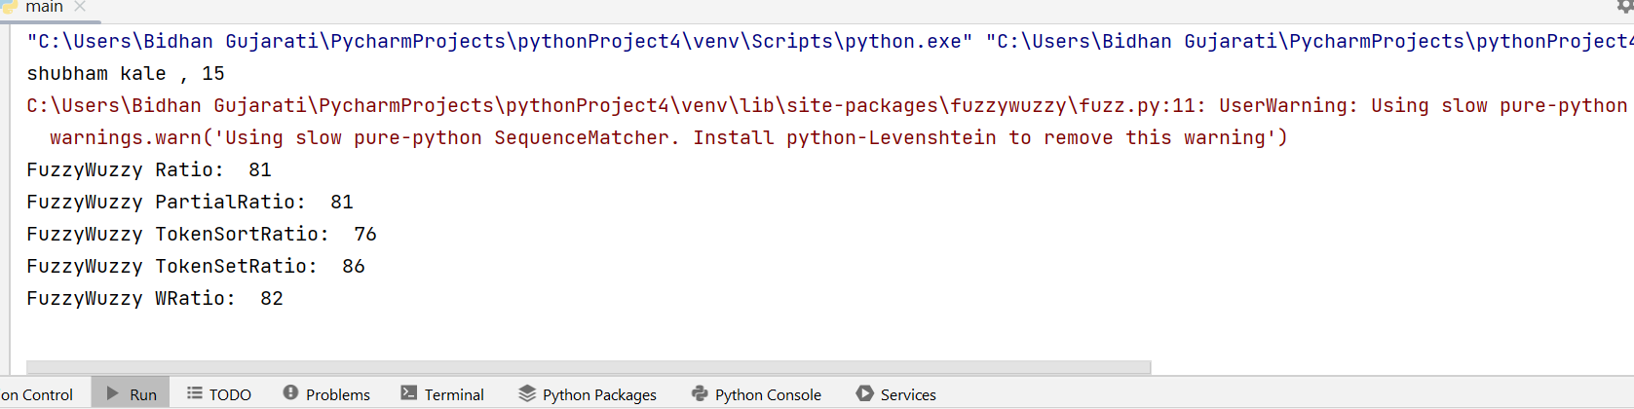

PRATICAL NO -5

Q5) Write an application using python to stimulate supervised learning model (Logistic Regression)

CODE:

print(‘shubham kale, 15)  
import pandas as pd  
from sklearn.model_selection import train_test_split  
from sklearn.preprocessing import StandardScaler  
from sklearn.linear_model import LogisticRegression  
from sklearn.metrics import confusion_matrix, accuracy_score  
  
*#Pandas used for reading the data*dataset=pd.read_csv("diabetes.csv")  
print(dataset.head())  
print(dataset.shape)  
x= dataset.iloc[:,[0,1,2,3,4,5,6,7]].values  
y=dataset.iloc[:,[-1]].values  
print(x)  
print(y)  
  
*#sklearn model used to split training and testing data*x_train, x_test, y_train, y_test=train_test_split(x,y, test_size=0.2,random_state=0)  
  
*#Standard scalar used to give structure to the dataset*sc= StandardScaler()  
x_train_new=sc.fit_transform(x_train)  
y_test_new=sc.fit_transform(y_test)  
  
print(x_train_new[0:15,:])

OUTPUT:

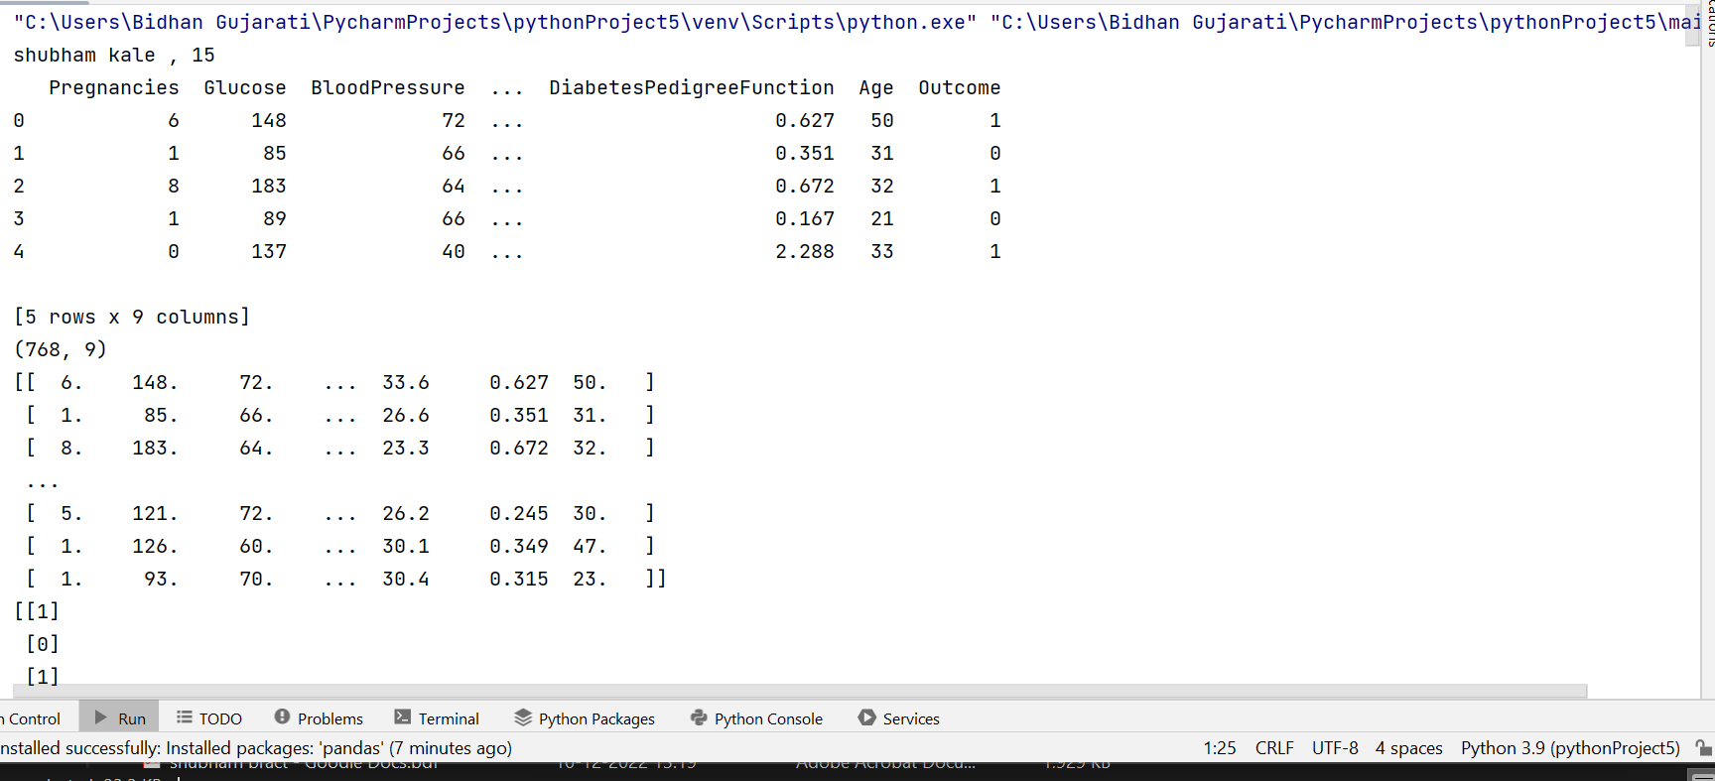

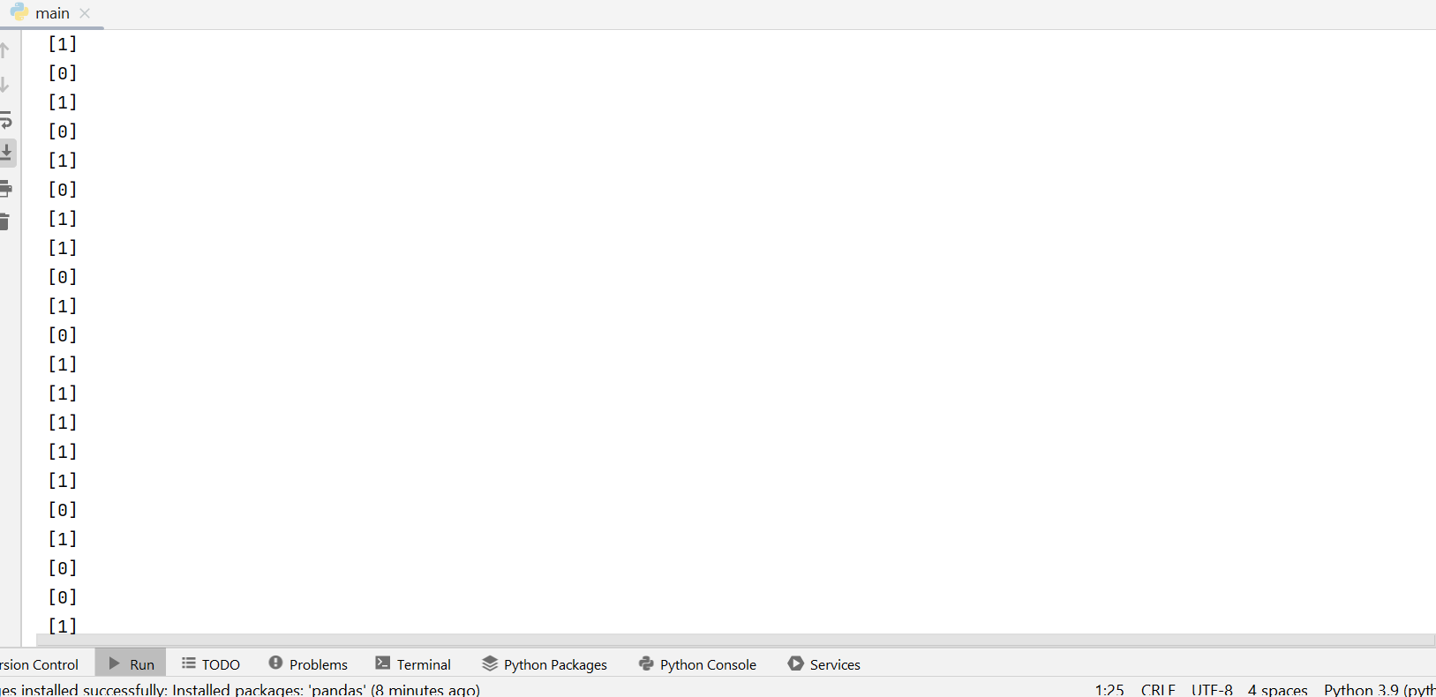

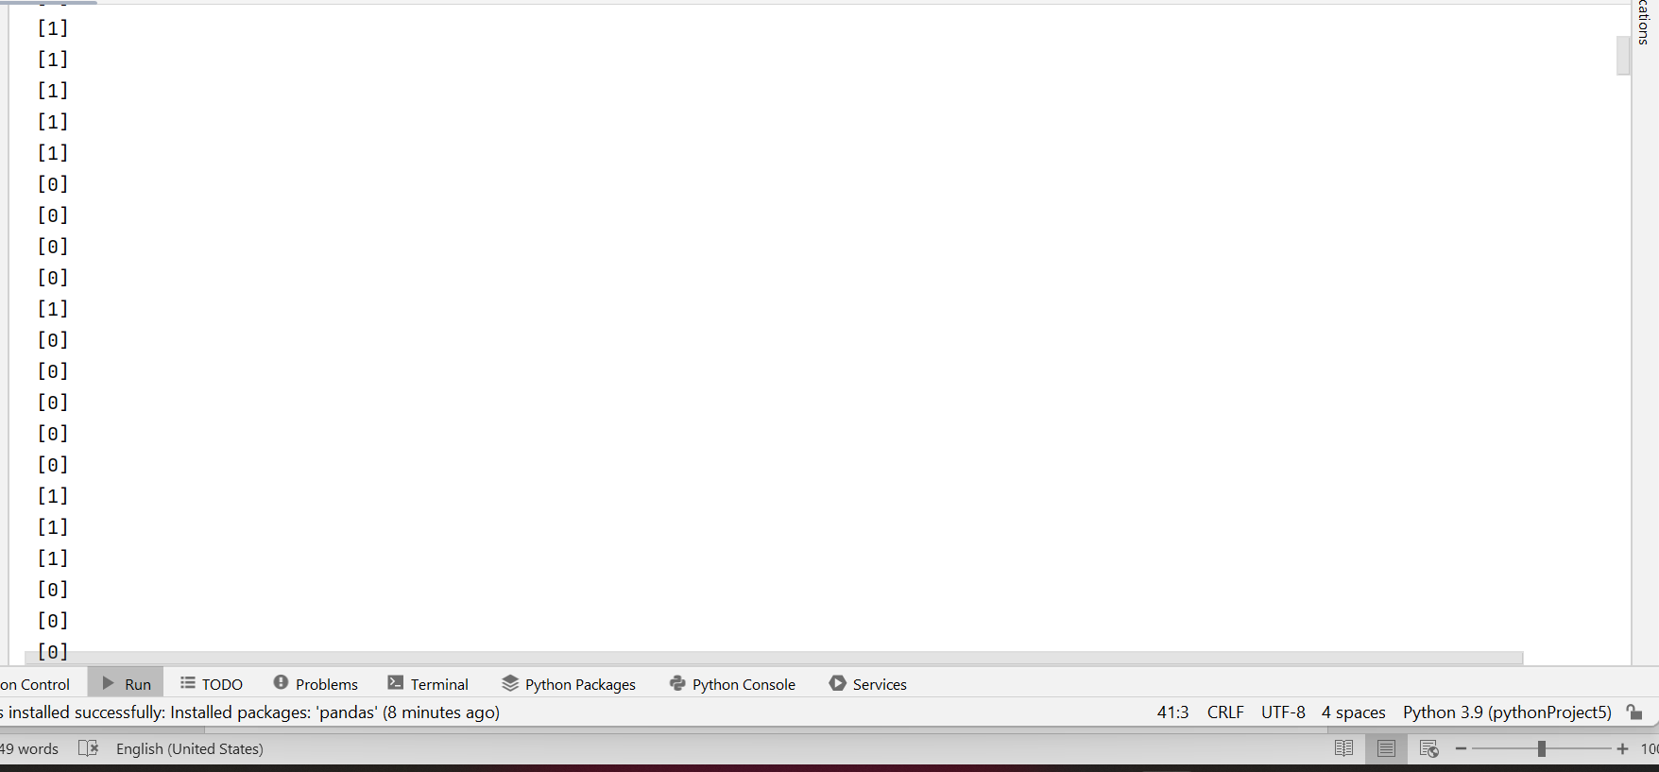

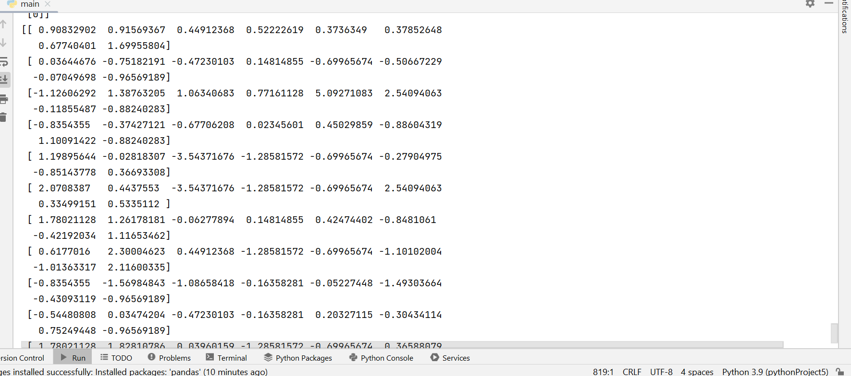

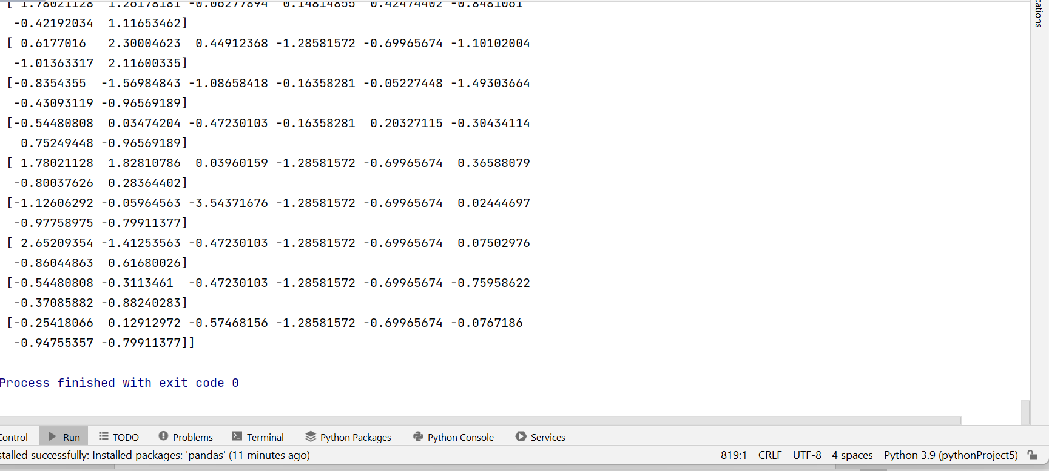

Practical 6

Q6) Fuzzy Logic : Membership in and not in and Identity Operators is, is not.

Code:-

print(‘shubham kale, 15’)

a = 10

b = 20

list = [1, 2, 3, 4, 5 ];

if a in list:

print ("Line 1 - a is available in the given list")

else:

print ("Line 1 - a is not available in the given list")

if b not in list :

print ("Line 2 - b is not available in the given list")

else:

print ("Line 2 - b is available in the given list")

a = 2

if a in list :

print ("Line 3 - a is available in the given list")

else:

print ("Line 3 - a is not available in the given list")

Output:-

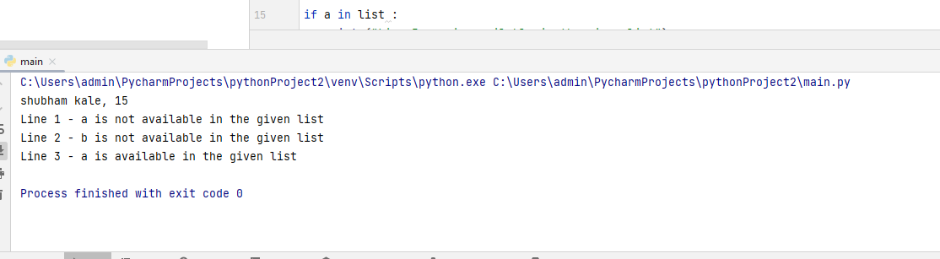

Practical 7

Q7) Write an application to simulate supervised

Code:-

print(‘shubham kale, 15’)

import numpy as np  
import matplotlib.pyplot as plt  
import pandas as pd  
from sklearn.linear_model import LogisticRegression  
from sklearn.metrics import confusion_matrix, accuracy_score  
from sklearn import datasets

*#inporting the datasets*datasets = pd.read_csv("iris.csv")  
datasets.describe()

*#spliting the datasets into the traning set and test set*x = datasets.iloc[:, [0,1,2,3]].values  
y = datasets.iloc[:, 4].values  
from sklearn.model_selection import train_test_split  
X_train, X_test, y_train, y_test = train_test_split(x,y, test_size= 0.25, random_state= 0)  
from sklearn.preprocessing import StandardScaler  
sc = StandardScaler()  
X_train = sc.fit_transform(X_train)  
X_test = sc.transform(X_test)

*#fitting logistic regression to the traning set*classifier = LogisticRegression(random_state = 0, solver= 'lbfgs', multi_class= 'auto')  
classifier.fit(X_train, y_train)

*#predicting the test set results*y_pred = classifier.predict(X_test)  
from sklearn.metrics import confusion_matrix  
cm = confusion_matrix(y_test, y_pred)  
print(cm)  
print("Accuracy:",accuracy_score(y_test,y_pred))

Output :-

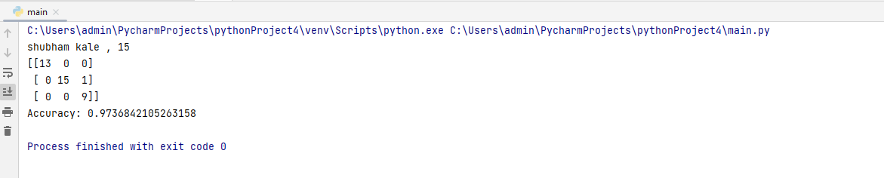

Practical 8

Q8) Write a Program to implement BFS algorithm.

Code :-

print(‘shubham kale, 15’)

import collections  
*#BFS algorithm*def bfs(graph, root):  
 visited, queue = set(), collections.deque([root])  
 visited.add(root)  
 while queue:  
 vertex = queue.popleft()  
 print(str(vertex) + "", end="")  
 for neighbour in graph[vertex]:  
 if neighbour not in visited:  
 visited.add(neighbour)  
 queue.append(neighbour)  
if __name__ =='__main__':  
 graph = {0: [1,2], 1:[2], 2:[3], 3:[1, 2]}  
 print("following is breadth first traversal: ")  
 bfs(graph, 0)

Output :-

